한국언어연구학회 2020년 춘계학술대회 발표요지문, “just a draft”
“An Alleviation of Locality Constraint in English Extraposition Construction”

발표자: 홍성심 (충남대학교, vshong@cnu.ac.kr)
일시: 2020.8.25-8.31
학회형식:온라인 (on-line)

I. Goals:
In a language like English, there exists some phenomena from which an expression cananot be moved. This has been known as a syntactic island. For example Wh-movement is not allowed crossing more than two bounding nodes, a version of Locality Constraint. Complex NP constraint, Coordinate structure constraint, Wh-island, Sentential Subject constraint, Adjunt island constraint, etc.

The purpose the present work is to provide a finer-grained clausal architecture to the structures of those sentences. In particular, there is an asymmetry between Sentential CP (finite and non-finite) and extraposed CP (finite and non-finite). Those sentential CPs headed either by an indicative C, that, or by a prepositional C, for, disallow Wh-extraction out of the CP, whereas those extraposed CPs headed either by that', or by for, allow Wh-movement out of the CPs.

The question is how we can account for this asymmetry between the sentential subject CP (SS CP) and the extraposion construction (EC CP), if they actually are of the isomorphic clausal types. Also, is the extraction out of the SS CP really a case of Subjacency violation (now that the SSCP examples are ungrammatical) within a more recent development of DP-hypothesis and Phasehood theory of movement (Chomsky 2000, 2001)? How can we rule out the ungrammatical ones of SSCP whereas letting the grammatical ones (ESCP) in?

This paper deals with what goes behind the rightward movement, if Extraposition is a rightward movement (assuming that rightward movement is adjunction)
'

II. Sentential Subject CP and its corresponding Extraposed CP:

The topic of syntactic islands has always been the center of syntactic research, since Ross (1967). It has long been observed that there is a syntactic dependency between the thematic position of Wh-expression and its surface landing site. If a transformational rule cannot extract some element out of a syntactic configuration, it is called “an island”. In Boecks (2012), he attributes to Freidin (1992: 94) what an island is: “A construction from which a constituent may not be moved by a transformation is designated as an island (following Ross 1967)”.

Although most of generative syntacticians including Chomsky (2000, 2001), Radford (2004, 2009), Boecks (2012), and Sportiche, Koopman, and Stabler (henceafter, SKS, 2014), take the stance that islands are syntactic phenomena, following Ross and Chomsky, some still consider this type of syntactic dependency as processing difficulties (Givon 1979, Kluender 2004, Hoffmeister & Sag 2010).
Boecks (ibid) points out that long distance syntactic dependency is a mirage, reinforcing that all movement be local in order to lessen the burden of cognitive processing. This particular point yields a variety of locality constraints. Just to name a few, cyclicity in the 70’s, subjacency and Barriers in the 80’s-90’s, and phase impenetrability condition(PIC) since the Minimalist syntax (Chomsky 2000, 2001).

Out of a wide range of syntactic islands, sentential subjects have also been discussed from the early times on. Consider and compare the following examples from Ross (1967), McCawley (1988), Boecks (2012), and SKS (2014), etc.

2.1. Core Data:

In this Section, I present two types of CP, finite and non-finite, in Sentential Subject Construction. I further discuss two types of CP, finite and non-finite in Extraposed complement clause.

(1) that-CP 절주어구문 (시제절)
a. [That Chloe kissed Dennis] bothered John==> Setential subject(SS)
b. It bothered John [that Chloe kissed Dennis] ==> Extraposition construction
c. [That John had read Chomsky's MP] surprised Ruth ==>Setential subject
d. It upset Ruth [that John had read Chomsky's MP]==> Extraposition construction
(2) for-CP 절주어구문 (비시제절)
a. [For Alice to eat many oysters] would be vulgar. ==>Setential subject (SS)
b. It would be vulgar [for Alice to eat many oysters]==>Extraposition construction
c. [For you to charge this boat on your credit card]] would be a disaster ==> Sentential subject
d. It would be a disaster [for you to charge this boat on your credit card] ==Extraposition construction

In all of the above examples in (1), (1a) and (1c) are sentential subject construction, headed by the indicative C, that. On the other hand, examples in (1b) and (1d) are extraposed counterpart. 'That'-CP is extraposed to the sentence final position. The only difference is that in EC constructions, the surface subject position is filled with an expletive, 'it'.
The same pattern is ound in (2a)-(2b)-(2c)-(2d), as well. (2a) and (2c) are non-finite sentential subjects whereas (2b) and (2d) are non-finite extraposed sentential subjects. The non-finite sentential subject, headed by prepositional C, 'for, is extraposed to the sentence final position. Again, the only difference between SSs, finite or non-finite, and ESs, finite or non-finite, is that in EC constructions, the surface subject position is filled with an expletive, 'it'.
As has been well known, Wh-movement is normally sensitive to what everyone calls “the island effects”, and the sentential subjects is one of those most distictive syntactic islands, also known as Sentential Subject Constraint.(SSC). The syntactic dependency between the extractee, Wh-expression, in its thematic position to the landing site yields ungrammaticality. The problem is that it is not clear how any version of Locality Constraint handles the set of data, now that the bounding nodes, the cyclic nodes, or phases are not clearly capable of disallowing the data, albeit the sentences being ungrammatical. Therefore, consider the following:

(3) 절주어구문(시제절)에서의 Wh-이동
a. [That Mary kissed who(m)] bothered John
b.*Who did [that Mary kissed ▲] bother John?
c. [That [John had read which book]] surprised Ruth?
d.*Which book did [that [John had read ▲]] surprise Ruth?

(4) 절주어구문(비시제절)에서의 Wh-이동
a. [For Alice to eat how many oysters] would be vulgar.
b.*How many oysters would [for Alice to eat ▲] be vulgar?
c. [For you to charge what on your credit card] would be a disaster.
d. *What would [for [you to charge ▲ on your credit card]] be a disaster?

In (3), (a) and (c) are finite sentential CP headed by 'that', whereas (b) and (d) show that Wh-extraction is not allowed. This extraction of XP is obviously banned as (b) and (d) are all ungrammatical. Therefore, the sentential subject which is headed by a finite C as in that-CP, a syntactic island. On the other hand if the sentential subjects are extraposed to the end of the sentence, Wh-extraction is somehow allowed:

(5) Wh-movement out of Extraposed finite CP
a. It bothered John [that [Chloe kissed who]]
b. Who did [it bother John [that [Chloe kissed ▲]]]?

(6) 시제절후치구문에서의 Wh-이동
a. It surprised Ruth [that [John had read which book]]
b. Which book did [it surprise Ruth [that [John had read ▲]]]?

(7) 비시제절 후치구문에서의 Wh-이동
a. It would be vulgar [for [Alice to eat how many oysters]]
b. How many oysters would [it be vulgar [for [Alice to eat ▲]]]?

The examples in (5)-(6)-(7) show that Wh-extraction out of the extraposed CP, finite (5)-(6) or non-finite (7), is available. This grammatical contrast between (3b),(3d),(4b), (4d) in one hand and the (5b)-(6b)-(7b) on the other demands an account, since SS CP and EC CP do seem to have a parallell isomorphic clausal architectures.

To summarize what we have discusses, the following table may be of use:

(8) Summary Table for the core data

Clausal CPs | Tense types | canonical example | Wh-movement applied
sentential subject CP | (i) finite (that-CP) | That John had read the book would terrify Chomsky | *Which book would that John had read ▲terrify Chomsky?
 | (ii) non-finite  (for-CP) | For Alice to eat many oysters would be vulgar | *How many oysters would for Alice to eat ▲ be vulgar?
Extraposed CP | (i) finite (that-CP) | It surprised Chomsky that John had read the book | Which book did it surprise that John had read ▲?
 | (ii) non-finite  (for-CP) | It would be vulgar for Alice to eat that many oysters | How many oysters would it be vulgar for Alice to eat ▲?

The above summary table shows that regardless of whether there is a Tensed CP or non-finite CP, Wh-extraction behaves according to the surface structure position: the subject position of a tensed clause and the complement position of a higher predicate. Descriptively speaking, this might be a correct observation. How can we differentiate the CPs in the subject position from the CPs in the extraposed position?

Prior to my analysis on the island alleviation over the extraposed CPs (5,6,7), let us make sure that (3b, 3d, 4b, 4d) are some kind of locality violation. That is, whether they violate the syntactic island constraint, to begin with.

Then we move on to the extraposed CPs. Then we may find any structural reasons why the EC is less sensistive to the syntactic island. It is assumed that some kind of locality constraints like Subjacency is at work, where DP and TP are bounding nodes in English, may not account for the ungrammaticality of the sentences in (3b)-(3d)-(4b)-(4d), while allowing (5b)-(6b)-(7b).

2.2. NP sitting on sentential subject CP?

Let us take what McCawley (1988: 529-530) has done for the sentential subject CP as opposed to the extraposed CP. He has posited an NP sitting on top of an S. Turning all the labels into a bit more recent ones, DP sitting on top of TP. Without much discussion, McCawldy provide his treediagram for a sentential subject CP and Extraposed CP as follows:

(9) McCawley의 예문
a. [That [for pigs to fly] is impossible]] is clear
b. That [it is impossible [for pigs to fly]] is clear

c. S

NP VP

Comp'

Comp S3
that
NP VP be clear

Comp'

Comp S is impossible
for
pigs to fly

The tree diagram (c) is more complicated one by having a non-finite sentential for-CP inside the finite sentential that-CP in the subject position of the matrix clause. To see the internal structure of sentential CP that McCawley has taken, however, the readers are advised to pay attention to the dotted circle on S₃.
The NP sitting on top of Comp-bar (Comp') is already very peculiar in terms of either X-bar syntax or Merge operation in a more recent Minimalist projection system. Ignoring the projection computation for the present purpose, no lexical element can move out of, let say S₃. In passing, there are other configurations that have been proposed in the literature.
The exact nature and the internal structure of Extraposition may be a challenge for us. First, let us discuss some previous approaches in McCawley.

(10) Ross (1967) (11) Emonds (1976)

S S

NP V' S NP V'
it it
surprises me that he quit V' NP S

surprises me that he quit
(12) McCawley (1981) (13) Williams (1974)

S S

NP V' S S
it
V' S NP V' that he quit
it
surprises me that he quit surprises me

The variety of tree diagrams dealing with the Extraposed CP have appeared in a different forms and structures, requoted from McCawley (1988: 106). All 4 tree diagrams differ in terms of the structure of that-CP, although the adjunction portion of that-CP in (13) is closest to what has been proposed.

The sentential that-CP or for-CP is best presented in (8), although it is complex. Note that the above tree diagrams are from the early framework, so that V-bar (V') is nowadays a VP, S' is a CP, Comp is a C, etc. For an explicit account, consider the following:

(14)
a. For pigs to fly is impossible
b. [That [ [for pigs to fly] is impossible]] is unclear.
c. ___ [_{TP3} [_{CP2 _____} That [_{TP2} [_{CP1 ____} for [_{TP1} pigs to fly]] is impossible] is unclear]

(15)
a. That for which animal to fly is impossible is unclear
b.*Which animal is [ that [for which animal to fly] is impossible] unclear?

Suppose the visible structural representation of (14a) is (14c). If this is the case, then there is no way to rule this out based on some locality constraint: Notice that there are two potential Spec-CP position, through which Wh-expression ('which animal') can move to the surface landing site as (14c) indicates. This representation is not a violation of Subjacency. Therefore, it is necessary to posit a null D on top of those CPs. In this case (13b), there are two sentential subjects embedded one another. Both contain an overt Cs whose specifier position is empty. This should allow Wh-movement, and yet the sentence is ungrammatical. In order to guarantee that this extraction violates some constraint, the presence of a null DP is a must, it seems.

III. Internal Structures of SS CP and Extraposed CP

(16)
a. That John had read the book would terrify Chomsky
b.*Which book would that John had read ▲terrify Chomsky?
c. For Alice to eat many oysters would be vulgar
d.*How many oysters would for Alice to eat ▲ be vulgar?

(16b)
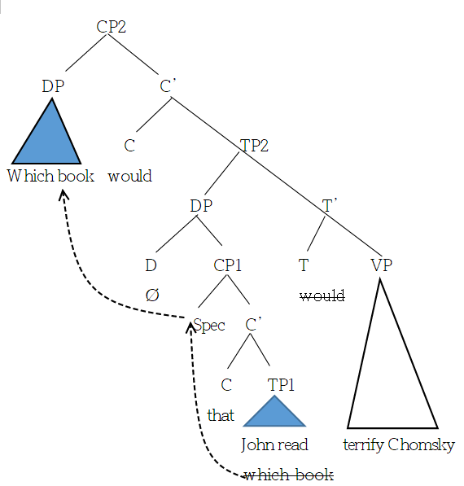

(17) Extraposed CP
a. It surprised Chomsky that John ate the lollipop
b. Which lollipop would it surprise Chomsky that John ate ▲?
c. It would be vulgar for Alice to eat that many oysters
d. How many oysters would it be vulgar for Alice to eat ▲?

(17) b.
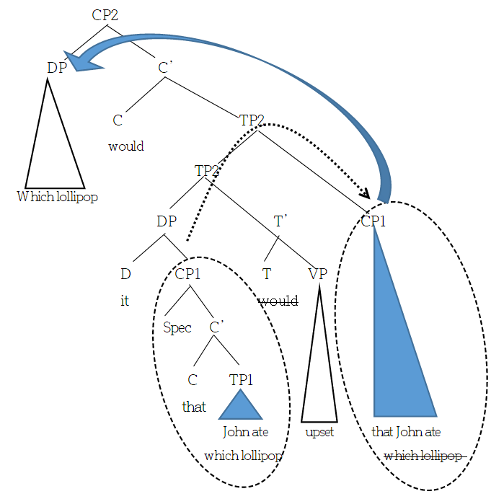

Step-by-step mechanism of Extraposition: once the CP1 right adjoins to TP2, the Wh-expression ('which lollipop') can undergo a series of successive cyclic movement via [Spec-CP1]. Under Phase-based locality, the C(of CP1) again is a phase-head and the complement of the phase can move into the Phase edge (Spec-CP1). Once it moved there the next step is the next phase higher up.

IV. Conclusion

All else being equal, syntactic dependency is found in English, one of which is Wh-movement. In some constructions like Sentential Subject CPs, Wh-extraction is not allowed. In some other constructions like extraposition constructions, Wh-movement is allowed. Island-sensitivity differs from one construction to another. In order to answer those questions, various approaches have been proposed. Huang (1982) has tried a diachotomy between adjuncts and complement. Rizzi has tried what is known as Relativized Minimality. I have tried to rely on one of the old versions of locality constraint, Subjacency. My proposal takes on Cartographic approach in that there are some specified null category structurally present. Extraposition takes place on CP alone, leaving a phonectically null (but with some features). One apparent advantage of my analysis is that it supports a presence of null D (and DP) sitting on top of the clausal subject. No other additional complication is necessary, except that DP and TP are two bounding nodes of English, unlike Italian, for example.

References are available in a published version of this paper

Ross (1967), Pulmutter (1972), Chomsky (1977), Radford (1988), Rizzi (1990), Postal (1998), Boecks (2012), and Sportiche, Koopman, & Stabler (2017) for extensive discussions of syntactic islands. In this paper, just one type of island, sentential subject as a syntactic island is discussed with a neutral stance on locality constraints in the literature.
One may try to do something like subject/complement or Adjunct/Complement asymmetry. Being said that, the sentential subjects are subjects and the subjects are adjunct whereas the extraposed clauses are complement clauses. (SKS, 2014). My intention is to stick to the clausal architecture, more like a Cartographic approach, instead of utilizing “subjecthood” as a grammatical primitives in the description.
His tree diagram is slightly altered for the brevity of presentation. See McCawley (1988: 529-530)

